The Annual Parish Meeting of Melmerby Parish
will convene at 7.30 p.m.
on Wednesday 27th March 2024
at Melmerby Village Hall

Press and public are welcome to attend.

AGENDA

- Welcome and introductions – Cllr Chris Jones, Chair, Melmerby Parish Council.

- Minutes of the Annual Parish Meeting held on 22nd March 2023.

- Information update from Melmerby Parish Council – Cllr Chris Jones, Chair, Melmerby Parish Council.

- Invitation to the public to discuss any matters of interest.

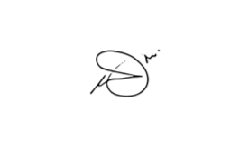
Chris Jones, Chair, Melmerby Parish Council

